# CS 255 System Design Document Template

## UML Diagrams

### UML Use Case Diagram

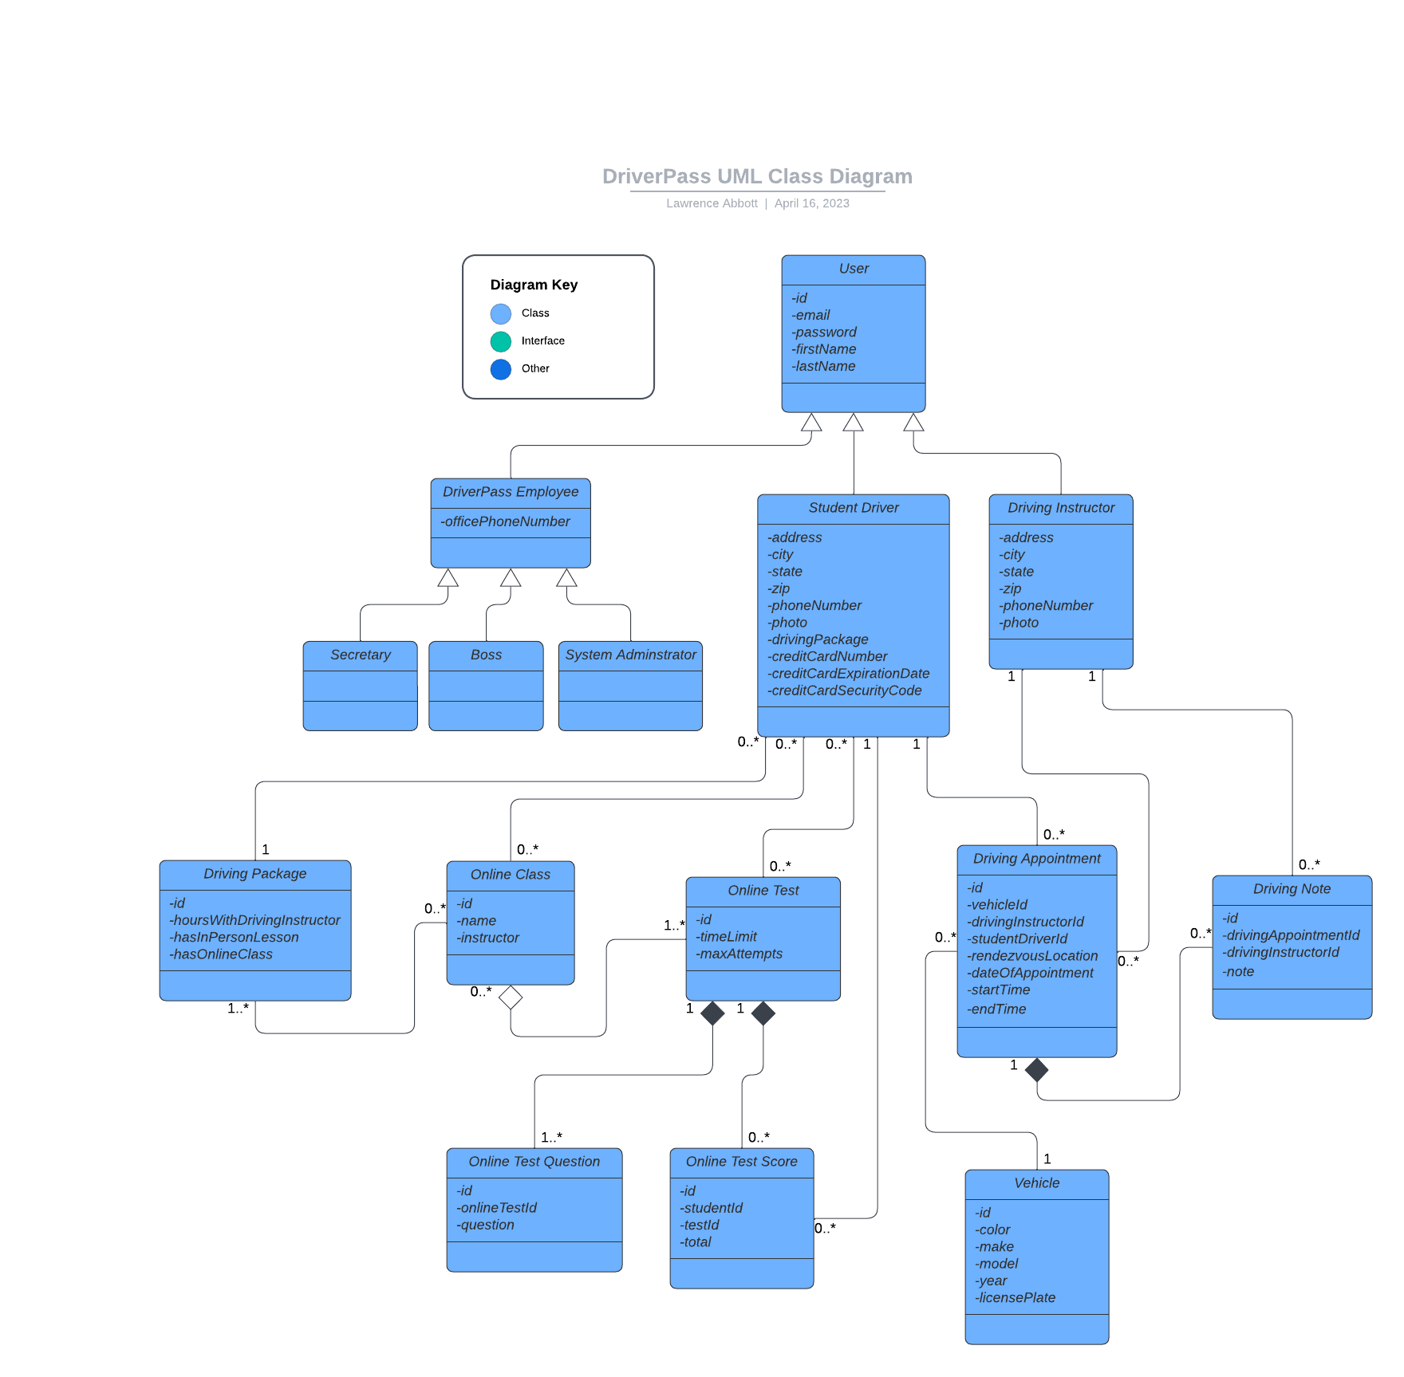

### UML Activity Diagrams

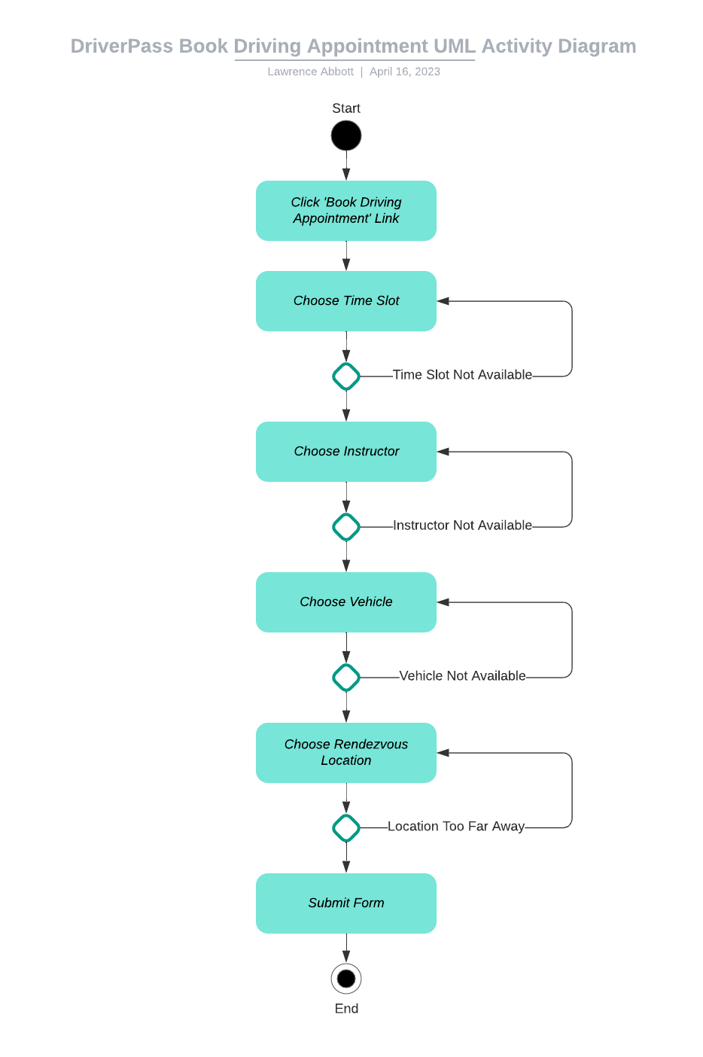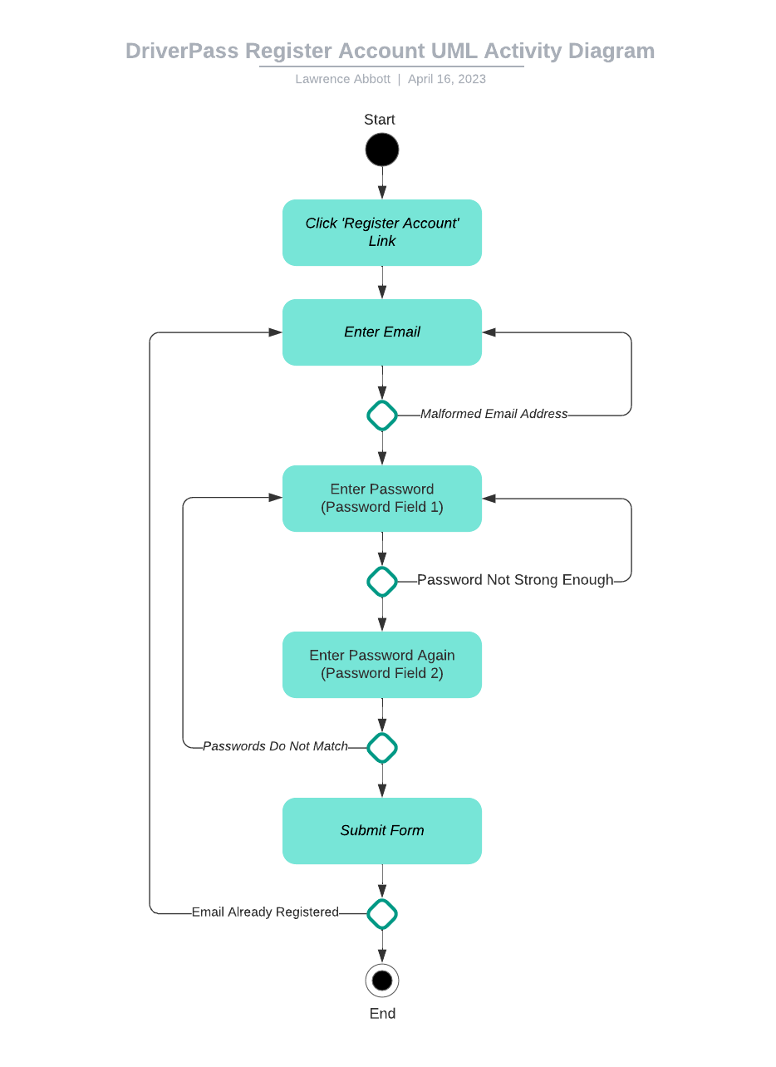

### UML Sequence Diagram

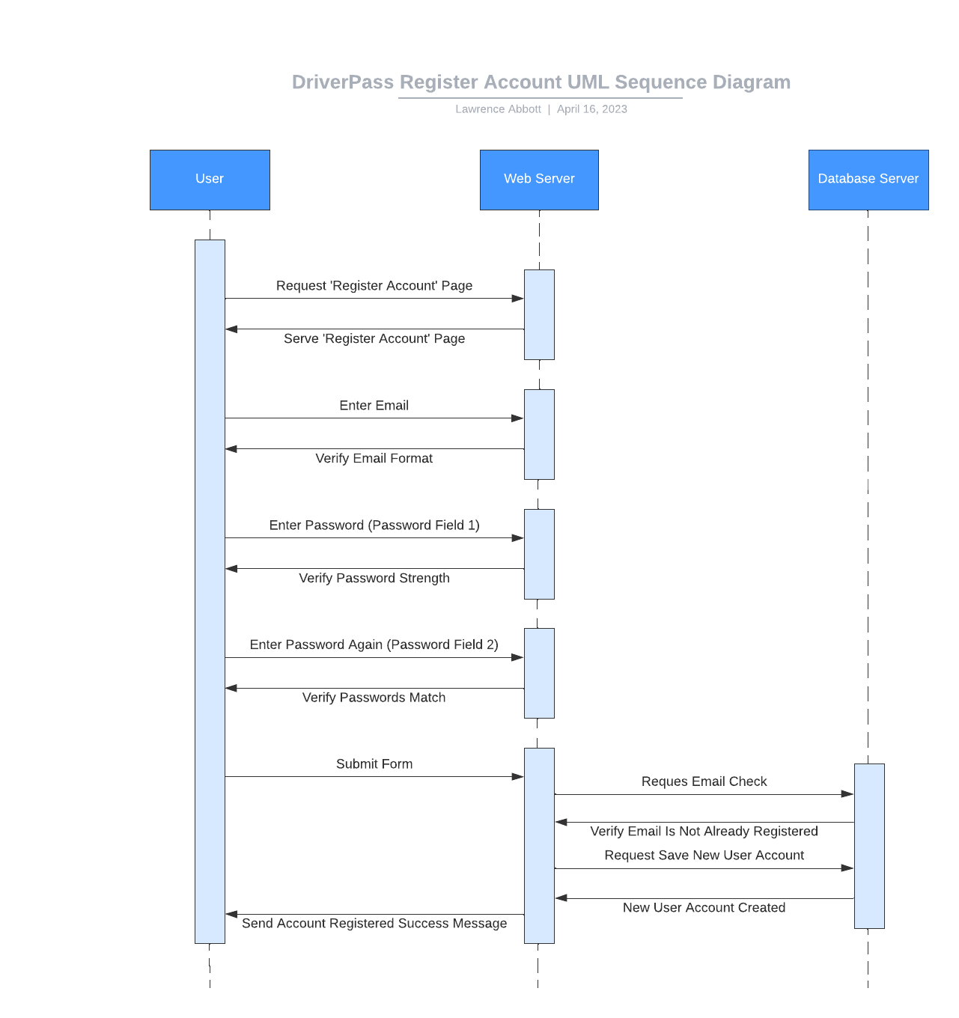

### UML Class Diagram



## Technical Requirements

* *The system shall be able to work in any web browser.*
* *The system shall identify users with a unique email address.*
* *The system shall validate users with an email and password.*
* *The system shall store passwords in a non-plain text manner; Passwords shall be encrypted with a salt and hash algorithm prior to being stored in the database.*
* *The system shall run on two servers; A database server, and a web server. Both of the servers will run a Linux operating system.*
* *The database server shall store records using a relational database; The database will be managed using MySQL database management software.*
* *The web server shall include the installation of NGINX web server software.*
* *The web server shall include installations of PHP and Laravel.*
* *The API shall be built using a CRUD paradigm, (Create, Read, Update, Delete).*
* *The web server shall harness a DMV API, if possible, for notifications and updates relating to driver education questions and content.*